Funciones

<http://www.php.net/manual/en/funcref.php>

**unset**

$isNull=unset();

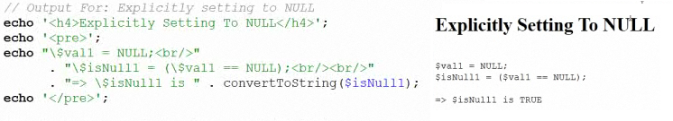

|  |  |
| --- | --- |
| **Casting** | **Is** |
| **(integer) (int**  **(float) (double) (real)**  **(string)**  **(bool)**  **(unset)**  **(array)**  **(object)** | **is_int**  **is_float() is_double() is_numeric()**  **is_string()**  **is_bool()**  **is_null()**  **is_array()** |

* $float1 = (float) $int1; // simple cast
* settype ($num, ‘bool’ ); // permanently change cast
* isset() test if the variable has been previously declared or has null value $bool1 = isset($a);

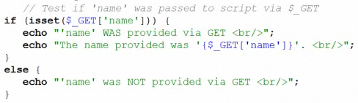

**Strings**

**Concatelation** $begin .= $end

$begin = $begin . $end

